Report: Safe and Effective Use of the Cottrell Two-Car Truck and QuiXspinz 2.0 Ratcheting System

Introduction
The Cottrell QuiXspinz Ratcheting System is an innovative and efficient solution designed to secure vehicles on car haulers. Developed by Cottrell, a leading name in car hauler manufacturing, this system aims to streamline the vehicle tie-down process, enhancing both efficiency and safety.

Overview of the QuiXspinz System
The original Cottrell QuiXspinz system was introduced as an upgrade option on Cottrell's NeXtgen soft tie equipment. The system allows operators to insert the tie-down bar only once when fastening the strap to the tire, reducing the time required for vehicle securement. The enhanced QuiXspinz 2.0 version has further improved efficiency by offering smoother operation and better ergonomics for varied weather conditions. Refer to Figure 1 for a visual demonstration.

How the Straps are Used
- Preparation: Position the vehicle on the trailer, ensuring proper alignment.
- Straps: Inspect the straps for wear and damage. Each strap has two 2" Swivel JHook
- Attaching the Strap: Place the strap over the tire and connect the two 2" Swivel J-Hooks to the truck's anchor points.
- 2" Swivel J-Hook: Each 2" Swivel J-Hook, as recommended by Cottrell, should be secured in the anchor point closest to the tire. This positioning ensures the JHook serves as a wheel chock, effectively preventing vehicle movement. Refer to Figure 2 for a visual demonstration.
- Threading the Strap into the Ratchet: Feed the free end of the strap through the slot in the ratchet's rotating spool. Pull the strap through it and leave some slack.
- Ratchet Spool. As recommended by Cottrell, align the ratchet spool directly with the tire and ensure that the spooled strap remains fully within it.
- Ratchet Shaft. The ratchet shaft allows the ratchet spool to move side-to-side, aligning directly with the strapped tire. If the strap crosses over the spool into the ratchet shaft, it can damage both the shaft and the strap, compromising the safety and functionality originally intended. See Figures 3, 4, and 5 for a visual reference.
- Tightening the Strap: Utilize the tie-down bar on the QuiXspinz ratchet and engage the ratcheting mechanism to securely fasten the strap, ensuring it is not over-tightened.
- Securing Excess Strap: Secure any excess strap to prevent it from flapping during transit.
- Final Inspection: Ensure the strap is properly positioned and the vehicle is stable.

Maintenance Recommendations
- Regularly inspect the QuiXspinz system for wear or damage.
- Keep the ratchet mechanism clean and lubricated for smooth operation.
Conclusion
The Cottrell QuiXspinz 2.0 Ratcheting System has proven reliable and effective for securing vehicles on car haulers. It offers speed, efficiency, and enhanced safety. It is recommended for use on various Cottrell trailers, including the CX-5308LS NextGen Quick Loader and the CX-09 LSFA 80-ft. trailer.
To fully utilize the safety features of the QuiXspinz ratchet systems, ensure all procedures are followed as recommended. Refer to the examples in Figures 1, 2, 3, 4, 5 and 6 to understand the consequences of incorrect usage and the proper procedures.

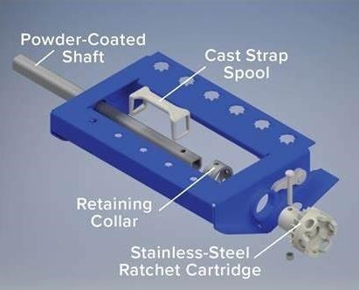
Figure 1 shows a Cottrell diagram showing all the parts involved in the assembly of the QuiXspinz.

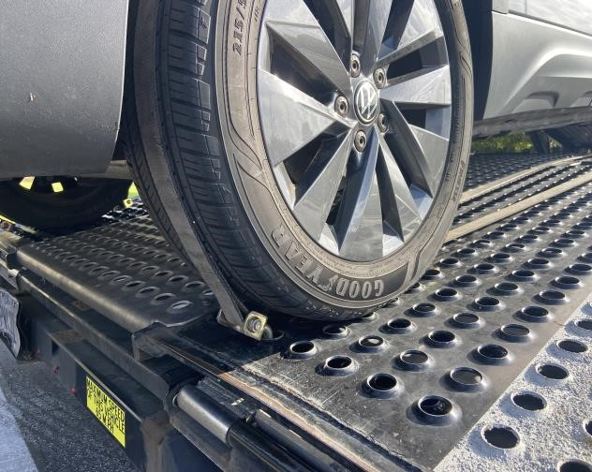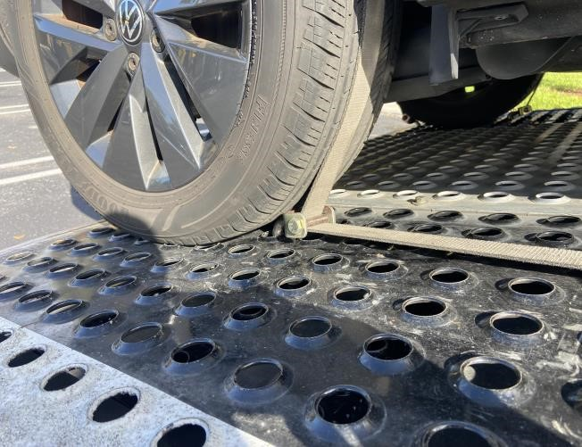
Figure 2 shows the proper strapping of a vehicle in a Cottrell Two-Car Truck. The Swivel J-hooks are connected to the nearest truck anchor to the tire and function as wheel shocks.

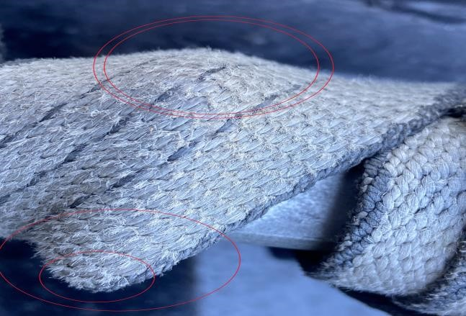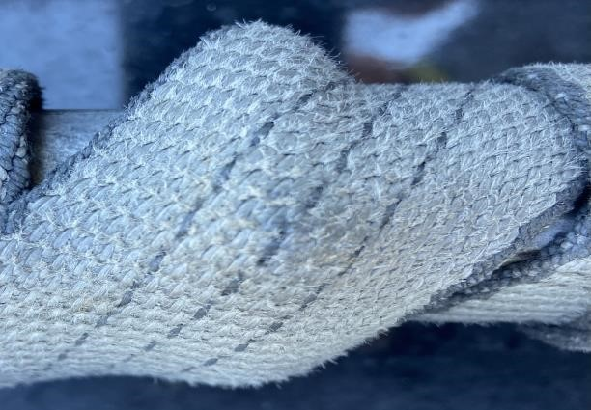
Figure 3: Improper Strapping Procedure. In these instances, the strap is damaged and has lost its functionality, reducing the safety and effectiveness intended by the Cottrell QuiXspinz Ratcheting System.
According to the Web Sling & Tie Down Association (WSTDA). When a strap is damaged (e.g., frayed, or worn), its load-bearing capacity can be significantly reduced, and even minor damage affects the strap's integrity. For example, a strap with visible fraying may lose up to 50% of its strength.

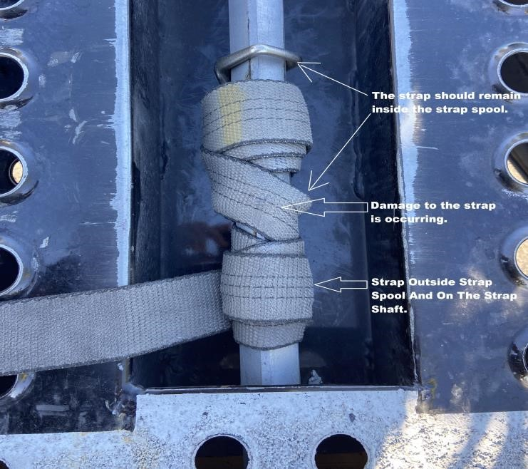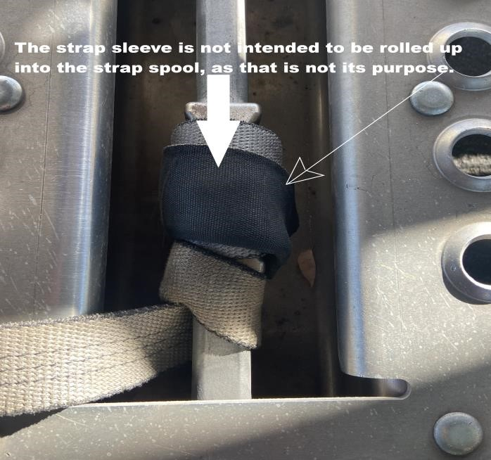
Figure 4: Improper Strapping Procedure. This incorrect use of tie-down straps can lead to strap failure, increasing risks and compromising the safety these straps are designed to provide.
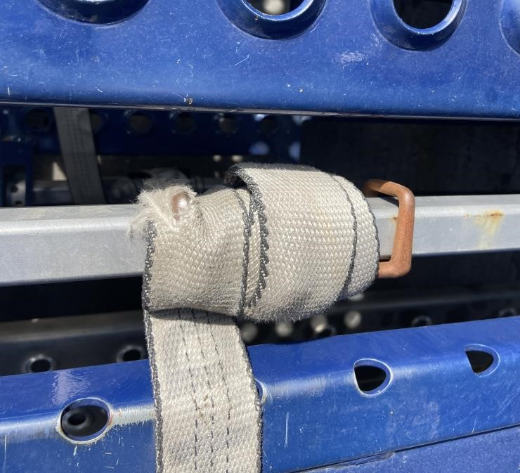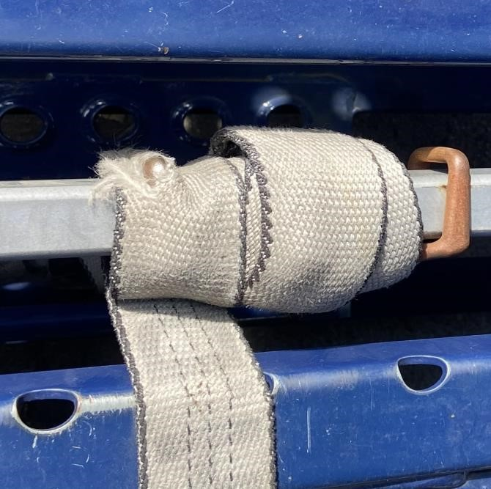

Figure 5: Improper Strapping Procedure. These examples clearly highlight the importance of adhering to proper procedures when using the Cottrell QuiXspinz Ratcheting Systems.

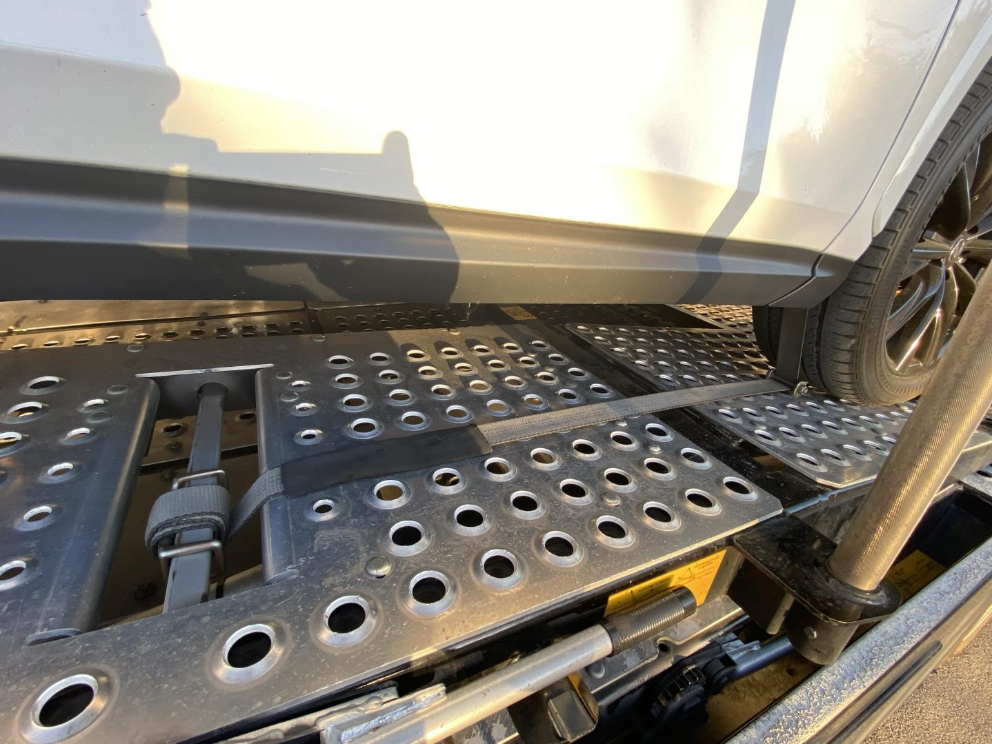
Figure 6: Displays a vehicle securely tied down in compliance with Cottrell QuiXspinz Ratcheting Systems specifications. The Swivel J-hooks are attached to the truck anchor point closest to the tire, functioning as wheel chocks. The ratchet spool, strap, and tire are perfectly aligned in a straight line. Additionally, the strap is fully contained within the strap spool.
Written by: Gustavo Guallar
Created on: March 20, 2025

